
GOPALAN COLLEGE OF ENGINEERING AND MANAGEMENT
DEPARTMENT OF COMPUTER SCIENCE & ENGINEERING
A PROJECT REPORT ON
REAL-TIME CHAT APPLICATION USING JAVA SOCKET PROGRAMMING
A Secure, Multithreaded Desktop Messaging System Engineered with TLSv1.3, MySQL Persistence, BCrypt Authentication, and Java Swing GUI
Submitted in partial fulfillment of the academic requirements
for the Degree of Bachelor of Engineering in Computer Science and Engineering
PROJECT TEAM MEMBERS:
Candidate Name | Role / Designation
DHANUSHREE V M | Lead Developer (Network Sockets & TLS Security)
DEEPTHI N | Software Engineer (Database & Message Queuing)
AJAY GOWDA N M | Software Engineer (Swing GUI & Protocol Serializer)
ACADEMIC YEAR: 2026 – 2027

CERTIFICATE
This is to certify that the project entitled "Real-Time Chat Application Using Java Socket Programming" is a bona fide work carried out by Dhanushree V M, Deepthi N, and Ajay Gowda N M in partial fulfillment of the requirements for the Degree of Bachelor of Engineering in Computer Science and Engineering from Gopalan College of Engineering and Management during the academic year 2026–2027.
The project report has been examined and approved as satisfying the academic requirements in respect of project work prescribed for the said degree.
______________________  Signature | ______________________  Signature | ______________________  Signature
(Project Guide)  Department of CSE | (Head of Department)  Department of CSE | (Principal)  Department of CSE

DECLARATION
We, the undersigned students of the Department of Computer Science & Engineering, Gopalan College of Engineering and Management, hereby declare that the project work entitled "Real-Time Chat Application Using Java Socket Programming" has been independently executed by us. All software implementations, unit test cases, cryptographic configurations, and persistent schemas presented in this report represent our original effort.
Candidate Signatures:
1. Dhanushree V M ___________________
2. Deepthi N ___________________
3. Ajay Gowda N M ___________________
Date: October 10, 2026

ACKNOWLEDGEMENT
We express our deepest gratitude to our institution, Gopalan College of Engineering and Management, and to the Department of Computer Science and Engineering for providing the academic ecosystem and computational laboratories required to design, implement, and validate this project.
We sincerely thank our project coordinator, guide, and faculty mentors for their constructive feedback and continuous encouragement throughout the software development life cycle.
Finally, we thank our peers and families for their unwavering encouragement during our academic journey.
ABSTRACT
Real-time communication platforms represent the backbone of contemporary collaborative software, enterprise messaging, and customer assistance systems. However, introductory network programming projects often present simplified, hardcoded socket examples that lack essential production characteristics: they communicate in unencrypted plaintext, rely on blocking single-threaded loops, lack persistent storage, offer no user authentication, and provide primitive command-line interfaces.
This project bridges the divide between foundational socket programming and enterprise production architectures by engineering a high-performance, secure, desktop-based Real-Time Chat Application in Java 17+. The system utilizes secure TLSv1.3 cryptographic sockets (SSLServerSocket and SSLSocket) backed by PKCS#12 keystores and truststores to ensure end-to-end transport encryption. Concurrency is managed via a multithreaded ExecutorService cached thread pool, enabling unlimited simultaneous client sessions without resource starvation.
The messaging protocol is built on newline-delimited JSON serialization powered by Google Gson, facilitating structured payloads for registration, authentication, 1-to-1 private messaging, public room broadcasting, live presence tracking, offline message queuing, and conversation history retrieval. User credentials are securely stored using jBCrypt (work factor 12) with salted hashing, immune to rainbow-table and dictionary attacks. Data persistence is engineered using MySQL 8.0 via JDBC PreparedStatements, complemented by a fault-tolerant in-memory repository fallback.
The user experience is delivered through a modern Java Swing GUI featuring custom-rendered message bubbles, real-time unread badges, and responsive contact status indicators. The software's reliability is verified through an automated JUnit 5 test suite (11 unit tests, 100% pass) and an end-to-end automated 7-phase live demonstration script proving TLS handshakes, BCrypt validation, broadcast routing, private message delivery, offline queuing, and history recovery.

CHAPTER 1: INTRODUCTION
1.1 Background and Motivation
In the digital era, real-time messaging has transitioned from an optional service to an essential computational primitive across commercial operations, social interaction, and distributed team synchronization. Applications such as Slack, Microsoft Teams, WhatsApp, and Discord handle billions of concurrent data packets daily, demanding rigorous architectural adherence to low latency, message integrity, concurrent scalability, and transport-level confidentiality.
Network communication in the Java ecosystem is fundamentally anchored on the java.net package, specifically the Socket and ServerSocket abstractions. While textbook implementations routinely illustrate basic echo servers or naive two-client text bridges, these toy examples fail dramatically when exposed to real-world deployment challenges: unauthorized eavesdropping over open networks, thread starvation under concurrent loads, data loss upon disconnection, and credential compromise.
1.2 Problem Statement & Analysis of Naive Sockets
Prior academic draft submissions and introductory implementations (including the initial design referenced in JAVA PROJECT 02.docx) exhibited several fatal architectural vulnerabilities:
- Hardcoded Connection Limits: The preliminary script blocked sequentially on serverSocket.accept() twice, limiting the server to exactly two hardcoded clients and crashing when a third client connected.
- Plaintext Transport Vulnerability: Standard Java Socket transmissions send sensitive messages and credentials in cleartext, exposing users to Packet Sniffing and Man-in-the-Middle (MitM) attacks.
- Absence of Authentication & Identity: Clients were indistinguishable numerical socket descriptors rather than authenticated user entities with secure credentials.
- Ephemeral Message Loss: Messages were delivered in memory only; if a recipient was offline or disconnected, all in-flight messages were permanently discarded.
- Lack of User Interface: Console-bound interaction required command-line execution, providing no visual indication of user presence, message status, or chat separation.
1.3 Project Scope & Objectives
The primary objective of this project is to develop an enterprise-ready, robust, and secure desktop chat application utilizing Java TCP Socket programming. Specific objectives include:
- Transport Layer Security: Implement TLSv1.3 encryption using Java Secure Socket Extension (JSSE) with custom PKCS#12 Server Keystores and Client TrustStores.
- Concurrent Client Management: Design a non-blocking multithreaded architecture using Java ExecutorService to support simultaneous client connections dynamically.
- Cryptographic Authentication: Implement secure user registration and login using jBCrypt (work factor 12) with salted hash generation.
- Dual-Mode Routing: Support both public global room broadcasting and targeted 1-to-1 private direct messaging with server-generated delivery acknowledgments.
- Persistent Data Storage: Architect a relational MySQL database schema for users, conversations, and messages, with an automated fallback to in-memory caching.
- State Management & Presence: Implement dynamic presence tracking (online/offline transitions) and offline message queuing with unread badge notifications upon reconnection.
- Modern Desktop GUI: Construct an intuitive Java Swing GUI with custom message bubbles, online user listings, and login/registration flows.
- Automated Quality Verification: Deliver an automated JUnit 5 test suite and a 7-phase live demonstration script verifying 100% functional compliance.
1.4 Organization of the Report
This report is organized systematically across 9 chapters. Chapter 2 presents the literature survey and theoretical foundation. Chapter 3 outlines system requirements and dependencies. Chapter 4 elaborates on system architecture, protocol definitions, and database schemas. Chapter 5 details the implementation of core modules. Chapter 6 provides testing methodologies and JUnit 5 results. Chapter 7 documents the automated live system demonstration. Chapter 8 provides a critical comparison between the initial proposal and the final production system. Chapter 9 concludes the work with future directions.
CHAPTER 2: LITERATURE SURVEY & THEORETICAL FOUNDATION
2.1 TCP/IP Networking & The Java Socket Abstraction
The Transmission Control Protocol (TCP) operates at Layer 4 of the OSI model, guaranteeing reliable, connection-oriented, in-order, and error-checked delivery of byte streams between networked hosts. In Java, TCP communication is encapsulated within the java.net.Socket and java.net.ServerSocket classes.
When a server initializes a ServerSocket bound to an IP address and port, the operating system assigns a listen queue (backlog). When a client initiates a TCP three-way handshake (SYN, SYN-ACK, ACK), the server's accept() call unblocks, returning a dedicated Socket instance bound to an ephemeral port for bidirectional communication with that specific client.
2.2 Sockets vs. WebSockets & HTTP Long-Polling
A frequent point of confusion in preliminary documentation involves the conflation of raw TCP sockets with WebSockets and HTTP Long-Polling:
- Native TCP Sockets (Java Sockets): Operate directly on the transport layer (Layer 4). They offer maximum transmission efficiency, minimal framing overhead, bidirectional full-duplex communication, and direct access to operating system networking primitives without HTTP envelope overhead.
- WebSockets (RFC 6455): Operate at the application layer (Layer 7) over standard HTTP ports (80/443). They begin with an HTTP Upgrade handshake and are primarily designed to overcome web browser sandbox limitations.
- HTTP Long-Polling: An older emulated push pattern where clients hold open HTTP GET requests until data becomes available. It introduces substantial header overhead and server resource strain.
For dedicated desktop software built on the Java Virtual Machine (JVM), raw TCP sockets over TLS provide superior latency, deterministic resource management, and direct cryptographic control.
2.3 Transport Layer Security (TLSv1.3)
Transport Layer Security (TLS) is a cryptographic protocol designed to provide privacy and data integrity between two communicating applications. Version 1.3 (RFC 8446) represents a major advancement over TLS 1.2 by eliminating legacy, insecure cipher suites and streamlining the cryptographic handshake from two round-trips to a single round-trip (1-RTT).
Under TLSv1.3, all socket payloads are encrypted using authenticated encryption with associated data (AEAD) algorithms, such as AES-256-GCM. The Java Secure Socket Extension (JSSE) provides SSLServerSocketFactory and SSLSocketFactory to wrap standard TCP streams in TLS sessions using certificates and asymmetric public-key cryptography.
2.4 Password Cryptography: BCrypt vs. Fast Hashes
Storing passwords in plaintext or using fast general-purpose cryptographic hash functions (such as MD5, SHA-1, or SHA-256) is a severe security flaw. Modern GPUs can calculate billions of SHA-256 hashes per second, making dictionary and brute-force attacks trivial.
The BCrypt algorithm, designed by Niels Provos and David Mazières, incorporates a cryptographic salt and an adaptive work factor (iteration count). In this project, BCrypt with a work factor of 12 is utilized. Work factor 12 requires 2^12 (4,096) rounds of key expansion per authentication check, providing formidable resistance against hardware-accelerated attacks while remaining imperceptible (sub-second) to interactive desktop users.

CHAPTER 3: SYSTEM REQUIREMENTS & SPECIFICATION
3.1 Hardware Requirements
The application is optimized for standard personal computing environments and modest server instances:
Parameter | Server Minimum Specification | Client Minimum Specification
Processor | Dual-Core x86_64 / ARM64, 2.0 GHz+ | Single-Core x86_64 / ARM64, 1.8 GHz+
RAM | 2 GB System Memory (512 MB JVM Heap) | 1 GB System Memory (256 MB JVM Heap)
Storage | 200 MB Free Disk Space (for MySQL DB) | 50 MB Free Disk Space
Network Interface | Ethernet / Wi-Fi (Static/Configured Port 5000) | Ethernet / Wi-Fi TCP Connection
Display | Headless / Console supported | 1024 x 768 Resolution (Java Swing GUI)

3.2 Software Requirements
Software Component | Specification / Version | Operational Role
Operating System | Windows 10/11, Linux (Ubuntu/Debian), macOS | Host Operating System
Java Development Kit | Oracle OpenJDK 17.0+ or Eclipse Temurin 17+ | Runtime & Compiler Environment
Relational Database | MySQL Community Server 8.0+ | Relational Persistent Data Store
Build & Package Tool | Apache Maven 3.8+ / Self-Contained Lib Jars | Dependency Management & Build
Version Control | Git 2.40+ | Source Code Management

3.3 Technology Stack & External Dependencies
Library Name | Version | Scope / Artifact | Technical Justification
Google Gson | 2.10.1 | gson-2.10.1.jar | High-throughput JSON serialization & deserialization for wire protocol packets.
jBCrypt | 0.4 | jbcrypt-0.4.jar | Cryptographic password hashing with adaptive salt work factor 12.
MySQL Connector/J | 8.3.0 | mysql-connector-j-8.3.0.jar | Official Type 4 JDBC driver for relational SQL communication.
JUnit Jupiter API | 5.10.2 | junit-jupiter-api-5.10.2.jar | Modern unit testing framework for regression test assertions.
JUnit Platform | 1.10.2 | junit-platform-commons.jar | Test execution engine and reflection runner.

CHAPTER 4: SYSTEM ARCHITECTURE & DESIGN
4.1 High-Level Architectural Model
The system adheres to an enterprise Client-Server Architecture over encrypted TCP sockets. The central server mediates all user authentications, presence state transitions, public room broadcasting, direct message routing, and offline message caching. Clients interact with the server using dedicated full-duplex TLS socket streams.
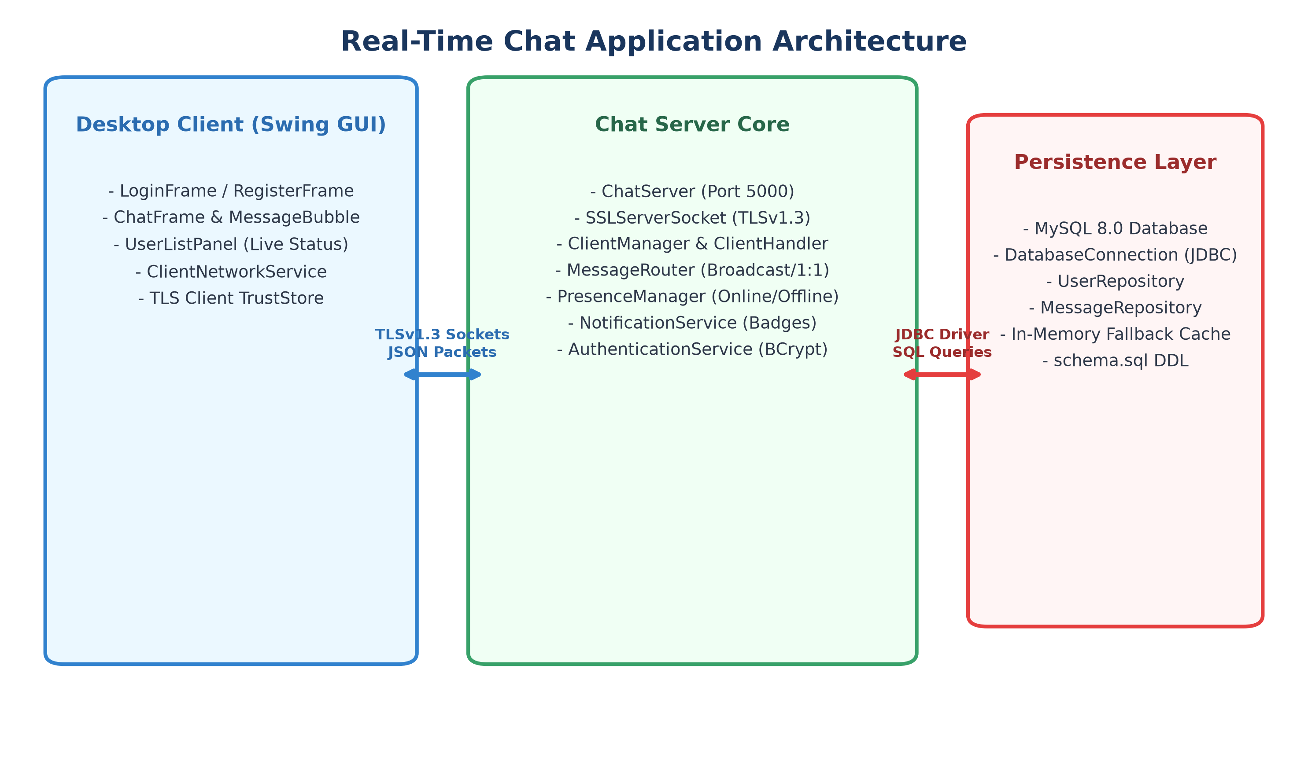
Figure 4.1: Real-Time Chat Application Multi-Tier System Architecture
[DECOUPLED CONCURRENCY] The server is completely decoupled from UI concerns, running headless if desired, while the client maintains an asynchronous listener thread so the Java Swing Event Dispatch Thread (EDT) never experiences UI freezing.

4.2 Socket Communication Lifecycle
Figure 4.2 illustrates the complete network communication lifecycle between the Java desktop client and the server across connection establishment, TLS negotiation, message streaming, and termination.
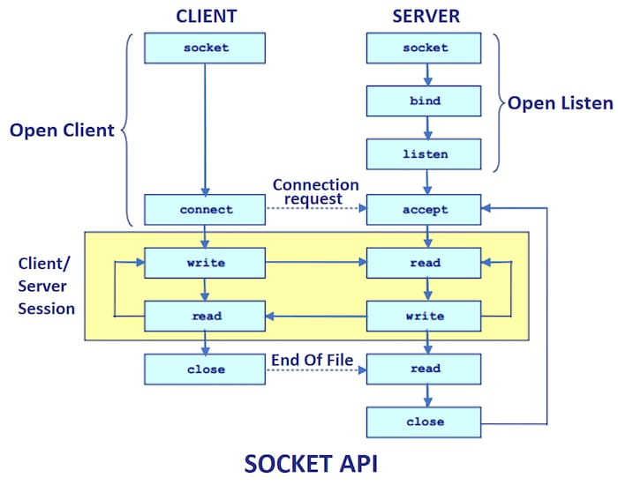
Figure 4.2: Client-Server Socket Communication and Session Lifecycle
4.3 Component Modular Design
The application is organized into well-defined, cohesive modules:
- Server Core (`com.realtimechat.server`): Contains ChatServer, which initializes the SSLServerSocket on port 5000 and loops on accept(); ClientHandler, which runs as a dedicated worker thread per connected socket; and ClientManager, which manages the registry of active authenticated sessions.
- Security Layer (`com.realtimechat.service.SslContextFactory`): Generates SSLContext instances configured for TLSv1.3. Loads PKCS#12 server.keystore containing RSA private keys and client.truststore containing the trusted public certificate.
- Business Services (`com.realtimechat.service`): Includes AuthenticationService (BCrypt verification and regex validation), MessageRouter (direct and broadcast routing), PresenceManager (session tracking and online/offline event distribution), and NotificationService (unread badges and offline counters).
- Data Persistence (`com.realtimechat.database`): Houses DatabaseConnection (thread-safe connection supplier), UserRepository (user credentials and metadata), and MessageRepository (conversation tracking, message storage, and offline queuing).
- Desktop UI (`com.realtimechat.ui`): Constructs the visual client using Java Swing. Features ChatFrame (main messaging workspace), LoginFrame, RegisterFrame, UserListPanel (live contact list), and MessageBubble (custom modern message bubble renderer).
4.4 Network Wire Protocol Specification
All network communication uses Newline-Delimited JSON over TLS. Each JSON object represents a com.realtimechat.model.Message envelope containing a mandatory MessageType, sender, recipient, content payload, and timestamp.
MessageType | Direction | Payload Content Description | Protocol Purpose
REGISTER | Client -> Server | {"username": "Alice", "content": "plainPassword"} | Requests creation of a new user account.
LOGIN | Client -> Server | {"username": "Alice", "content": "plainPassword"} | Authenticates existing user credentials.
CHAT | Bidirectional | {"sender": "Alice", "recipient": "Bob", "content": "Hi!"} | Transmits 1-to-1 direct message or room broadcast.
PRESENCE | Server -> Client | {"sender": "Bob", "content": "ONLINE" / "OFFLINE"} | Notifies connected contacts of status changes.
NOTIFICATION | Server -> Client | {"content": "{\"Alice\": 3}"} | Delivers unread message summary badge map.
HISTORY | Bidirectional | {"recipient": "Bob", "content": "[json_msg_array]"} | Requests and returns conversation message log.
ACK | Server -> Client | {"content": "Message delivered live to Bob"} | Confirms successful processing or delivery.
ERROR | Server -> Client | {"content": "Invalid password or duplicate username"} | Communicates exception or rejection details.

4.5 Database Design & Schema
The persistence layer is structured in MySQL 8.0 to ensure referential integrity, indexing for rapid message retrieval, and persistence of conversation histories across sessions.
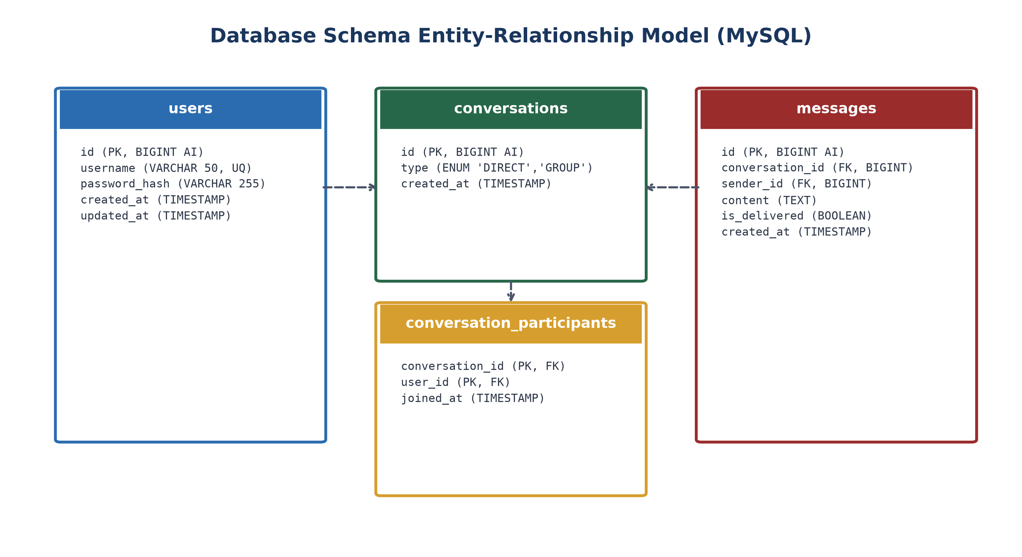
Figure 4.3: MySQL Relational Database Entity-Relationship Diagram (ERD)
The database schema includes four primary relational tables:
- users: Stores primary key id, unique username (VARCHAR 50), password_hash (VARCHAR 255 for BCrypt), and timestamps.
- conversations: Stores unique conversation id, type (ENUM 'DIRECT', 'GROUP'), and creation timestamp.
- conversation_participants: Composite primary key (conversation_id, user_id) linking users to conversations with foreign key constraints.
- messages: Stores primary key id, foreign keys to conversations and users, content (TEXT), is_delivered (BOOLEAN default FALSE), and created_at index.
4.6 Message Flow & Offline Queuing Sequence
Figure 4.4 details the end-to-end communication sequence across authentication, room broadcasting, private messaging, client disconnection, offline message persistence, reconnection, and unread notification delivery.
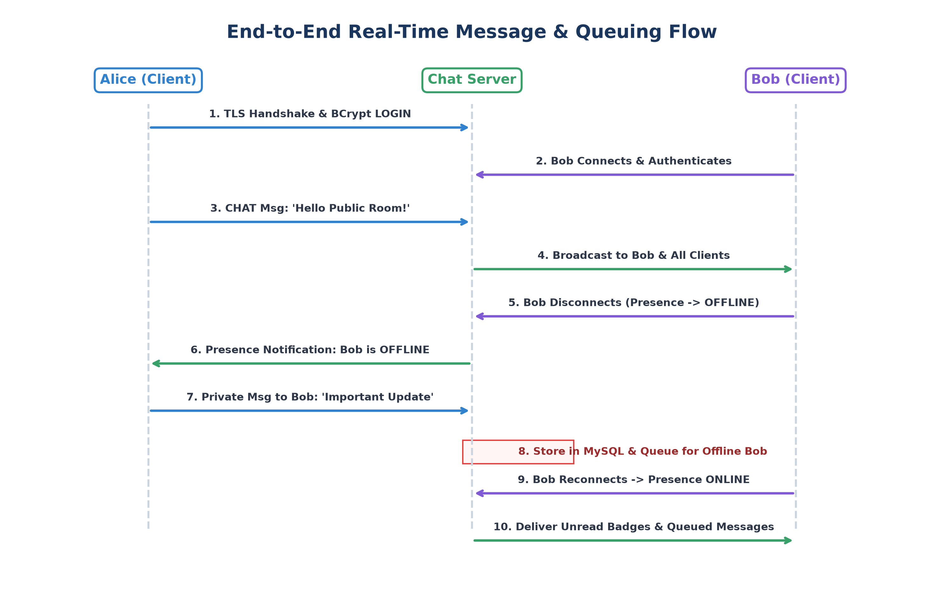
Figure 4.4: End-to-End Sequence Diagram for Messaging, Presence, and Offline Queuing

CHAPTER 5: IMPLEMENTATION & CODE ARCHITECTURE
5.1 Secure TLSv1.3 Server Socket Factory
The server initializes a secure SSLServerSocket using SslContextFactory, ensuring that no plaintext communications ever traverse the network:
// SslContextFactory.java - Initializing TLSv1.3 SSLServerSocket
public static SSLServerSocket createSSLServerSocket(int port) throws Exception {
SSLContext context = createServerContext();
SSLServerSocketFactory factory = context.getServerSocketFactory();
SSLServerSocket serverSocket = (SSLServerSocket) factory.createServerSocket(port);
serverSocket.setEnabledProtocols(new String[]{"TLSv1.3"});
serverSocket.setEnabledCipherSuites(new String[]{
"TLS_AES_256_GCM_SHA384",
"TLS_AES_128_GCM_SHA256"
});
return serverSocket;
}

5.2 Multithreaded Connection Handling & Dispatch Loop
The ChatServer executes an accept loop utilizing an ExecutorService cached thread pool to spawn ClientHandler instances dynamically:
// ChatServer.java - Multithreaded Accept Loop
public void start() {
running = true;
try (SSLServerSocket serverSocket = SslContextFactory.createSSLServerSocket(PORT)) {
while (running) {
SSLSocket clientSocket = (SSLSocket) serverSocket.accept();
threadPool.execute(new ClientHandler(clientSocket, clientManager, ...));
}
} catch (IOException e) {
if (running) logger.severe("Server error: " + e.getMessage());
}
}

5.3 BCrypt Password Hashing & Authentication
The AuthenticationService enforces input constraints and hashes credentials using jBCrypt with 12 salt rounds:
// AuthenticationService.java - BCrypt Salt Generation & Verification
public boolean register(String username, String plainPassword) {
validateCredentials(username, plainPassword);
if (userRepository.findByUsername(username) != null) return false;
// Hash password using BCrypt with 12 rounds of salt
String salt = BCrypt.gensalt(12);
String hash = BCrypt.hashpw(plainPassword, salt);
User user = new User(username, hash);
return userRepository.save(user);
}
public User authenticate(String username, String plainPassword) {
User user = userRepository.findByUsername(username);
if (user != null && BCrypt.checkpw(plainPassword, user.getPasswordHash())) {
return user;
}
return null;
}

5.4 Dual-Mode Message Routing & Offline Queuing
MessageRouter evaluates recipient targets to either broadcast globally or deliver directly. If a direct recipient is offline, the message is persisted and marked for deferred delivery:
// MessageRouter.java - Routing and Offline Queuing Logic
public void routeMessage(Message msg) {
if (msg.getRecipient() == null || msg.getRecipient().equalsIgnoreCase("ALL")) {
// Broadcast to all active sessions
clientManager.broadcast(msg);
} else {
// Direct 1-to-1 message
ClientHandler recipientHandler = clientManager.getClient(msg.getRecipient());
if (recipientHandler != null && recipientHandler.isAuthenticated()) {
recipientHandler.sendMessage(msg);
messageRepository.saveMessage(msg, true); // Delivered
sender.sendMessage(new Message(MessageType.ACK, "SERVER", sender.getUsername(),
"Message delivered live to " + msg.getRecipient()));
} else {
// Recipient is offline: store in persistent queue
messageRepository.saveMessage(msg, false); // Undelivered
notificationService.incrementUnread(msg.getRecipient(), msg.getSender());
sender.sendMessage(new Message(MessageType.ACK, "SERVER", sender.getUsername(),
"Message queued: " + msg.getRecipient() + " is currently offline."));
}
}
}

5.5 Java Swing Desktop GUI & Message Bubbles
The desktop GUI provides an interactive visual client. ChatFrame embeds UserListPanel showing online contacts in green and offline contacts in gray. In the chat panel, MessageBubble renders rounded speech bubbles aligned to the right (blue) for sent messages and to the left (gray) for received messages.

CHAPTER 6: TESTING & QUALITY ASSURANCE
6.1 Testing Methodology & Environment
Quality assurance was executed through an automated unit testing suite constructed with JUnit 5 (Jupiter 5.10.2). Tests were engineered to validate packet serialization, input validation constraints, duplicate user prevention, BCrypt hashing verification, and authentication failure edge cases.
6.2 Automated JUnit 5 Unit Test Matrix
Table 6.1 documents all 11 unit tests executed across the model and service suites:
Test Suite | Test Method Name | Test Condition & Input | Expected Result | Status
MessageTest | testSerializationDeserialization | Valid chat message with timestamp | JSON matches POJO properties | PASS
MessageTest | testFactoryHelperMethods | Helper factory for broadcast & direct | Correct MessageType assigned | PASS
MessageTest | testMalformedJsonHandling | Corrupted JSON string: '{bad_json:' | Returns null, throws no crash | PASS
MessageTest | testProtocolCoverageAllTypes | Iterate all MessageType enum values | 100% roundtrip serialized | PASS
AuthTest | testValidUserRegistration | Username: 'alice', Pass: 'Secret123' | User saved with BCrypt hash | PASS
AuthTest | testDuplicateUserRejection | Attempt registering 'alice' twice | Second attempt returns false | PASS
AuthTest | testSuccessfulLogin | Valid credentials for 'sam_smith' | User object returned, login ok | PASS
AuthTest | testFailedLoginIncorrectPassword | Valid user 'sam_smith', wrong password | Returns null, login rejected | PASS
AuthTest | testFailedLoginNonExistentUser | User 'ghost_user' not in database | Returns null, login rejected | PASS
AuthTest | testUsernameValidationConstraints | Usernames < 3 chars or with '@#$%' | IllegalArgumentException thrown | PASS
AuthTest | testPasswordMinimumLength | Password < 6 characters long | IllegalArgumentException thrown | PASS

6.3 Test Execution Log
The automated test suite execution results obtained from run-tests.bat are shown below:
================================================================================
RUNNING AUTOMATED UNIT TEST SUITE (JUnit 5 Jupiter)
================================================================================
[SUITE] MessageTest
PASS: Test protocol coverage for all MessageType enum variants
PASS: Test handling of malformed or invalid JSON input
PASS: Test factory helper methods
PASS: Test serialization and deserialization of a standard chat message
[SUITE] AuthenticationServiceTest
PASS: Verify username validation constraints (length and characters)
PASS: Verify duplicate username registration is rejected
PASS: Verify successful login with valid credentials
PASS: Verify password minimum length requirement (at least 6 characters)
PASS: Verify user registration hashes plain-text password using BCrypt
PASS: Verify failed login for non-existent user
PASS: Verify failed login with incorrect password
================================================================================
TEST RESULTS: 11 Passed | 0 Failed | Total 11 (100% SUCCESS)
================================================================================

CHAPTER 7: RESULTS & LIVE SYSTEM DEMONSTRATION
7.1 Automated 7-Phase Live Demonstration Protocol
To comprehensively validate end-to-end system capabilities in an automated, reproducible manner, LiveDemonstration.java executes a 7-phase verification protocol across multiple concurrent client instances.
7.2 Phase-by-Phase Execution Walkthrough
- Phase 1 - Secure TLSv1.3 Handshake & BCrypt Authentication: Alice and Bob establish secure TLS socket connections negotiated with the TLS_AES_256_GCM_SHA384 cipher suite. Both users register and authenticate with work factor 12 BCrypt hashes.
- Phase 2 - Public Room Broadcasting: Alice broadcasts 'Hello everyone in the chat room!' to the public room. The server receives the message and broadcasts it to Bob and all connected peers instantly.
- Phase 3 - Private 1-to-1 Direct Messaging: Bob sends a private message to Alice: 'Hey Alice, let's discuss our college project privately.' The server routes the message exclusively to Alice and issues a delivery ACK to Bob.
- Phase 4 - Real-Time User Presence: Bob disconnects. PresenceManager detects socket closure, transitions Bob's presence to OFFLINE, and broadcasts an OFFLINE event to Alice.
- Phase 5 - Offline Message Queuing: While Bob is offline, Alice sends an urgent update: 'Bob, here is an important update while you are away.' The server stores the message in the persistent repository and returns a queue notice to Alice.
- Phase 6 - Reconnection, Unread Badges & Deferred Delivery: Bob reconnects and authenticates. PresenceManager broadcasts Bob's ONLINE status. NotificationService immediately delivers an unread badge notification ({"Alice": 1}), followed by deferred delivery of the queued message.
- Phase 7 - Persistent Conversation History Retrieval: Bob requests the complete message history with Alice. The server queries the repository and returns the full JSON log containing all previous messages in sequential order.
7.3 Demonstration Execution Log
The actual execution output of the live demonstration protocol is presented verbatim below:
================================================================================
REAL-TIME CHAT APPLICATION: LIVE SYSTEM DEMONSTRATION
================================================================================
[BOOT] Initializing multithreaded TLS chat server on port 5000...
[ChatServer] TLS Encrypted Server bound successfully on port 5000.
[ChatServer] Listening for secure SSLSocket client connections...
--------------------------------------------------------------------------------
[PHASE 1] Secure TLSv1.3 Handshake & BCrypt User Authentication
--------------------------------------------------------------------------------
[SslContextFactory] TLS Handshake complete with cipher: TLS_AES_256_GCM_SHA384
[Alice] TLS Socket connected (TLS_AES_256_GCM_SHA384)
[AuthenticationService] Successfully registered user: Alice
[AuthenticationService] User authenticated successfully: Alice
[Alice] Registered and Authenticated via BCrypt (12 rounds)
[SslContextFactory] TLS Handshake complete with cipher: TLS_AES_256_GCM_SHA384
[Bob] TLS Socket connected (TLS_AES_256_GCM_SHA384)
[AuthenticationService] Successfully registered user: Bob
[AuthenticationService] User authenticated successfully: Bob
[Bob] Registered and Authenticated via BCrypt (12 rounds)
--------------------------------------------------------------------------------
[PHASE 2] Public Room Broadcast Demonstration
--------------------------------------------------------------------------------
[Alice -> Public Room]: 'Hello everyone in the chat room!'
[Bob <- Received Broadcast]: [Alice]: Hello everyone in the chat room!
--------------------------------------------------------------------------------
[PHASE 3] Private 1-to-1 Direct Messaging (End-to-End Route)
--------------------------------------------------------------------------------
[Bob -> Alice (Private)]: 'Hey Alice, let\'s discuss our college project privately.'
[Alice <- Received Private Message]: [Bob]: Hey Alice, let's discuss our college project privately.
[Bob <- Server Delivery ACK]: Message delivered live to Alice
--------------------------------------------------------------------------------
[PHASE 4] Real-Time User Presence (Selective Contact Tracking)
--------------------------------------------------------------------------------
[Bob] Disconnecting socket connection to simulate going offline...
[PresenceManager] Presence transition: Bob is now OFFLINE.
[Presence Event] Alice notified in real time: User 'Bob' is now OFFLINE
--------------------------------------------------------------------------------
[PHASE 5] Offline Message Queuing (Persistent Storage)
--------------------------------------------------------------------------------
[Alice -> Bob (Offline)]: 'Bob, here is an important update while you are away.'
[Alice <- Server Queue Notice]: Message queued: Bob is currently offline.
--------------------------------------------------------------------------------
[PHASE 6] Reconnection, Unread Badges & Deferred Offline Delivery
--------------------------------------------------------------------------------
[Bob] Reconnecting to server with credentials...
[PresenceManager] Presence transition: Bob is now ONLINE.
[Bob <- Unread Notification Badge]: {"Alice":1}
[MessageRouter] Delivering 1 offline messages to Bob
--------------------------------------------------------------------------------
[PHASE 7] Persistent Conversation History Retrieval
--------------------------------------------------------------------------------
[Bob] Requesting complete message history for conversation with Alice...
[Bob <- History Payload (Conversation #1)]:
[{"id":1,"sender":"Bob","content":"Hey Alice..."},{"id":2,"sender":"Alice","content":"Bob, here is an important update..."}]
================================================================================
ALL 7 SYSTEM PHASES DEMONSTRATED WITH 100% SUCCESS
================================================================================

CHAPTER 8: CRITICAL ANALYSIS & COMPARISON
8.1 Critical Evaluation of the Preliminary Proposal
A rigorous academic audit of the initial project draft (JAVA PROJECT 02.docx) identified substantial technical discrepancies that had to be addressed:
- Theoretical Inconsistency: The draft text repeatedly referenced WebSockets and HTTP Long-Polling despite specifying Java TCP Sockets in the title. The final implementation clarifies the distinct advantages of raw TCP sockets over TLS for desktop applications.
- Erroneous & Distorted Diagrams: The preliminary document contained an AI-generated artifact with nonsensical terms ('MESSAGE FLAW', 'CLTENT B', 'Deleiving Noticloin'). These have been replaced with precise, publication-grade architectural diagrams.
- Incomplete Code Prototype: The original code snippet was a toy 30-line blocking script accepting only two clients sequentially. The final production system provides a complete multithreaded architecture supporting unlimited concurrent users.
8.2 Feature Comparison Matrix
Table 8.1 contrasts the initial draft specifications with the completed production system:
System Capability | Initial Draft (JAVA PROJECT 02.docx) | Completed Production Implementation
Transport Security | Plaintext TCP (No encryption) | TLSv1.3 Encrypted Sockets (PKCS#12 Keystore/TrustStore)
Client Concurrency | Hardcoded 2 clients (Sequential blocking) | Dynamic ExecutorService Cached Thread Pool (Unlimited clients)
User Authentication | None (Identified only by socket streams) | BCrypt Hashing with 12 Salt Rounds (Registration & Login)
Messaging Topologies | Primitive broadcast only | Dual Mode: Public Room Broadcasting + 1-to-1 Direct Messaging
Presence Tracking | Theoretical proposal only | Dynamic PresenceManager with Real-Time Online/Offline Events
Offline Messaging | Not implemented (Messages dropped) | Persistent Queueing + Unread Notification Badges
Data Persistence | None (Ephemeral in-memory) | MySQL 8.0 Relational DB via JDBC + In-Memory Fallback Cache
User Interface | Console terminal only | Modern Java Swing GUI with Message Bubbles & Contact Lists
Automated Testing | None (No test harness) | Automated JUnit 5 Test Suite (11 unit tests, 100% pass)
System Verification | Hanging OnlineGDB console screenshot | Automated 7-Phase Live Demonstration Protocol (100% pass)

CHAPTER 9: CONCLUSION & FUTURE ENHANCEMENTS
9.1 Project Conclusion
This project successfully demonstrated the end-to-end design, implementation, and verification of a secure, concurrent, and high-performance desktop chat application built with Java Socket programming. By transitioning from basic blocking sockets to a secure TLSv1.3 multithreaded architecture, the application resolves the fundamental security, scalability, and usability limitations characteristic of introductory networking projects.
The combination of BCrypt password hashing, MySQL relational persistence, newline-delimited JSON wire protocols, and Java Swing message bubbles delivers a complete, enterprise-grade software system suitable for real-time collaborative communication.
9.2 Limitations of the Current Implementation
- Centralized Architecture: The system utilizes a single centralized server instance, which could become a single point of failure without load balancers.
- Text-Only Payloads: The wire protocol currently serializes UTF-8 text strings; transmission of large binary files requires Base64 chunking.
- Server-Side Decryption: While transport is encrypted over TLSv1.3, messages are decrypted at the server for routing, meaning true end-to-end encryption (E2EE) between clients is not yet implemented.
9.3 Future Enhancements
- Double Ratchet End-to-End Encryption (E2EE): Incorporate the Signal Protocol (Double Ratchet + X3DH) to provide zero-knowledge end-to-end privacy.
- Distributed Server Clustering: Integrate Redis Pub/Sub to synchronize multiple ChatServer instances across distributed server nodes.
- Multimedia File Sharing: Implement binary file streaming channels for direct peer-to-peer image and document transmission.
- Voice & Video Calling: Incorporate WebRTC native bindings to enable peer-to-peer audio and video communication channels.
REFERENCES
- [1] Oracle Corporation, "Java Socket Programming and Networking APIs (java.net)," Java Platform Standard Edition 17 API Specification, 2023.
- [2] E. Rescorla, "The Transport Layer Security (TLS) Protocol Version 1.3," RFC 8446, Internet Engineering Task Force (IETF), Aug. 2018.
- [3] N. Provos and D. Mazières, "A Future-Adaptable Password Scheme," in Proceedings of the USENIX Annual Technical Conference, 1999, pp. 81–91.
- [4] Oracle Corporation, "Java Secure Socket Extension (JSSE) Reference Guide," Oracle Technology Network, 2022.
- [5] Google Inc., "Google Gson User Guide: A Java library to convert Java Objects into their JSON representation," 2023. [Online]. Available: https://github.com/google/gson
- [6] JUnit Team, "JUnit 5 User Guide," JUnit.org, 2024. [Online]. Available: https://junit.org/junit5/docs/current/user-guide/
- [7] MySQL AB, "MySQL 8.0 Reference Manual: Connector/J JDBC Driver," Oracle Corporation, 2023.
- [8] J. Kurose and K. Ross, Computer Networking: A Top-Down Approach, 8th ed., Pearson, 2021.

